**Agent page loading error**

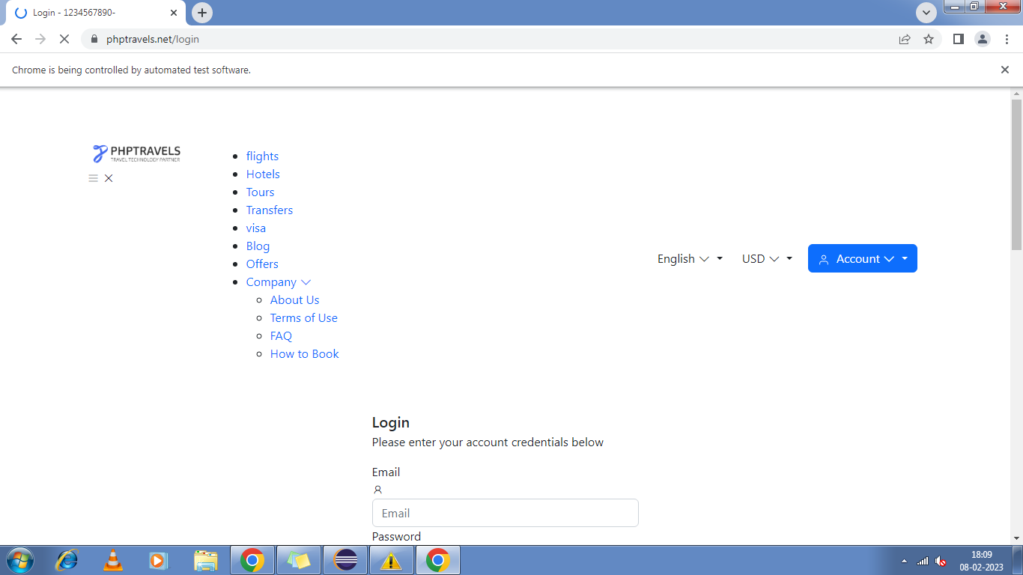

**By giving valid credentials for customer module its sometimes showing wrong credential**

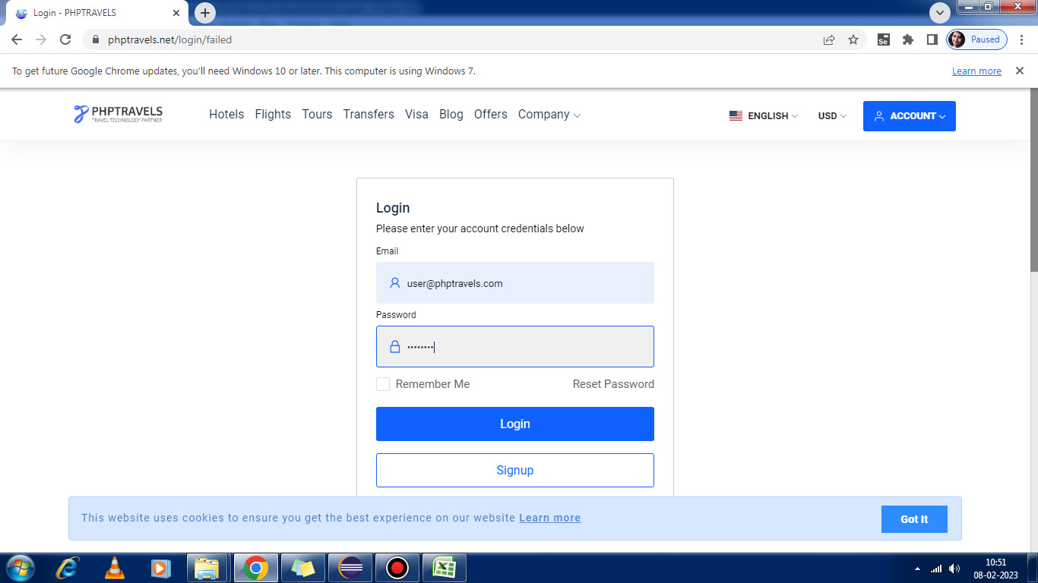

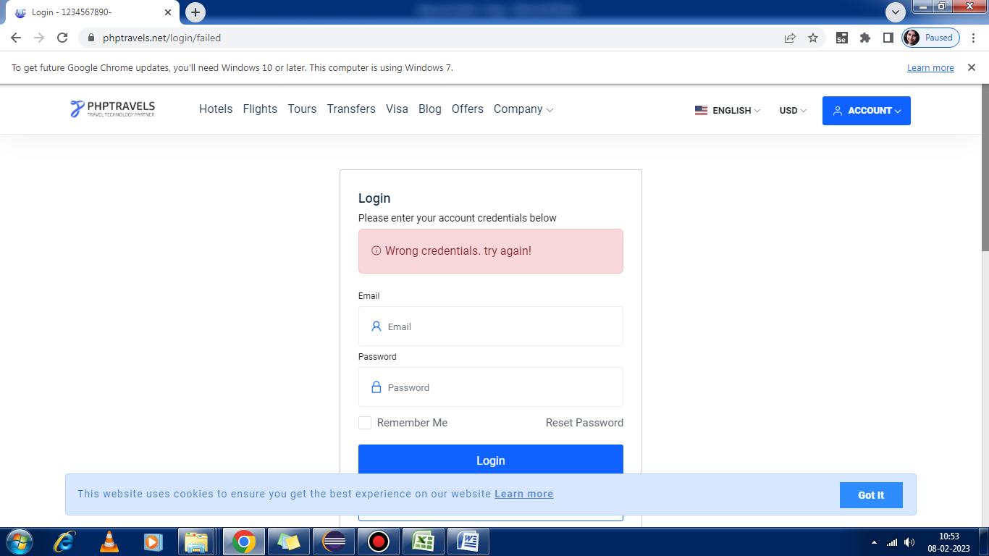

**Bug in the payment page of customer module**

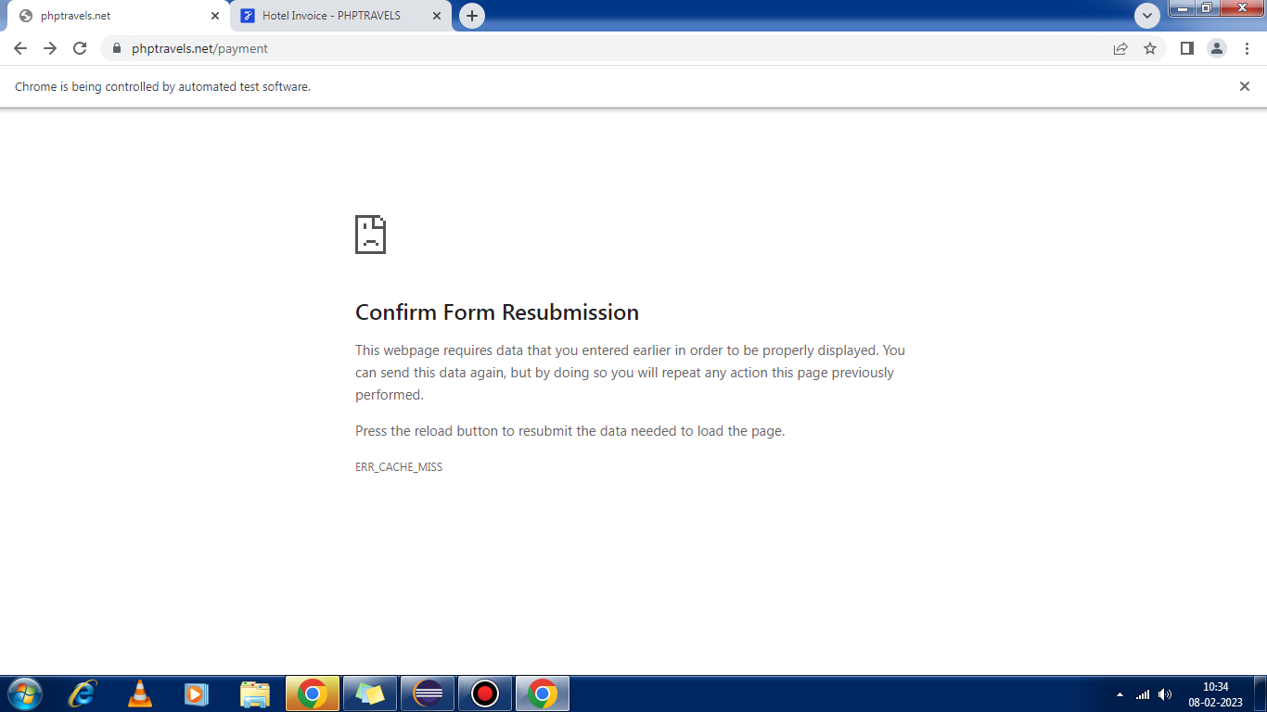

**Website link in admin module is not displaying every time**

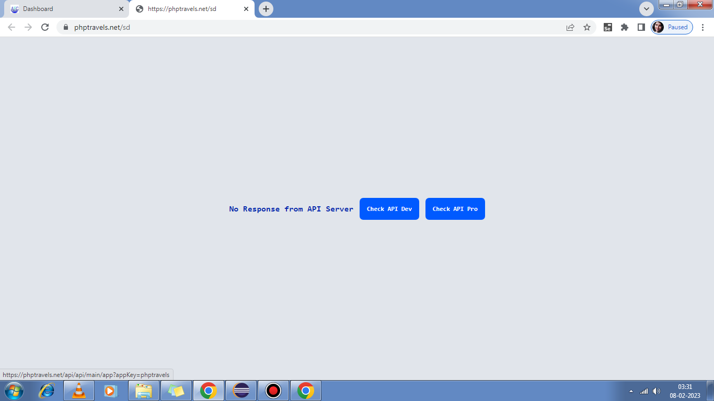

**Agent with valid login credential is getting an error message and then able to login**

**Home Page link in agent module is not working always**

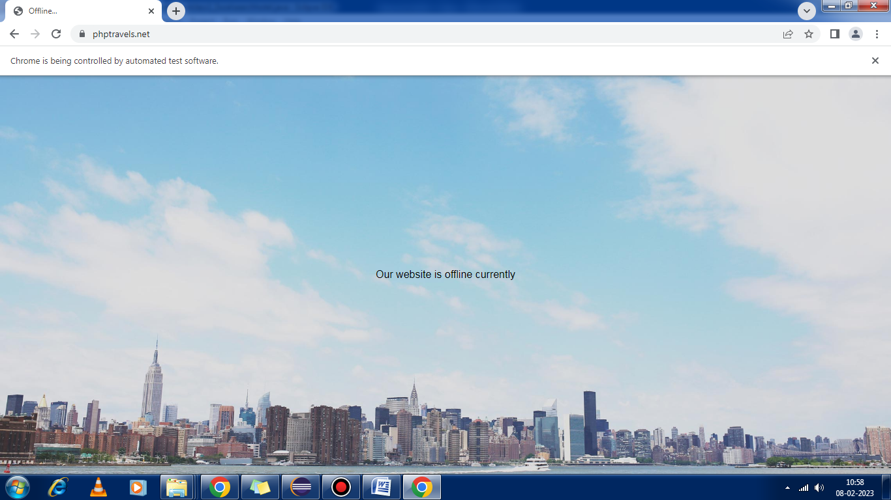

**Url not getting loaded all the time for customer module**

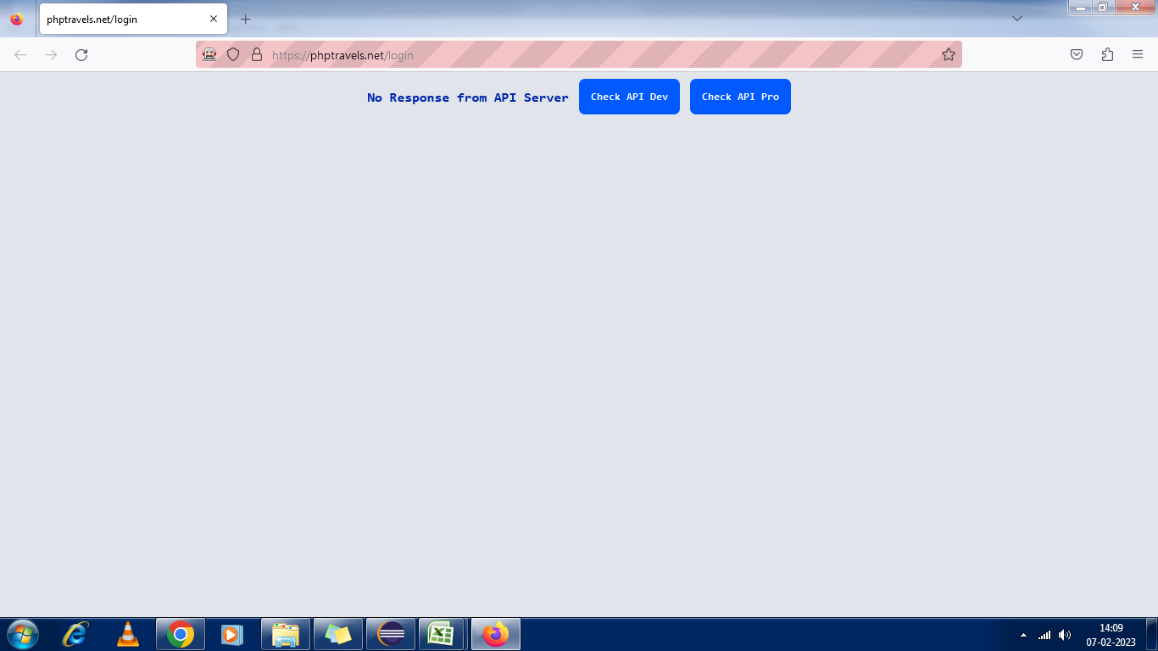

**Bugs in agent module for search hotel functionalty**

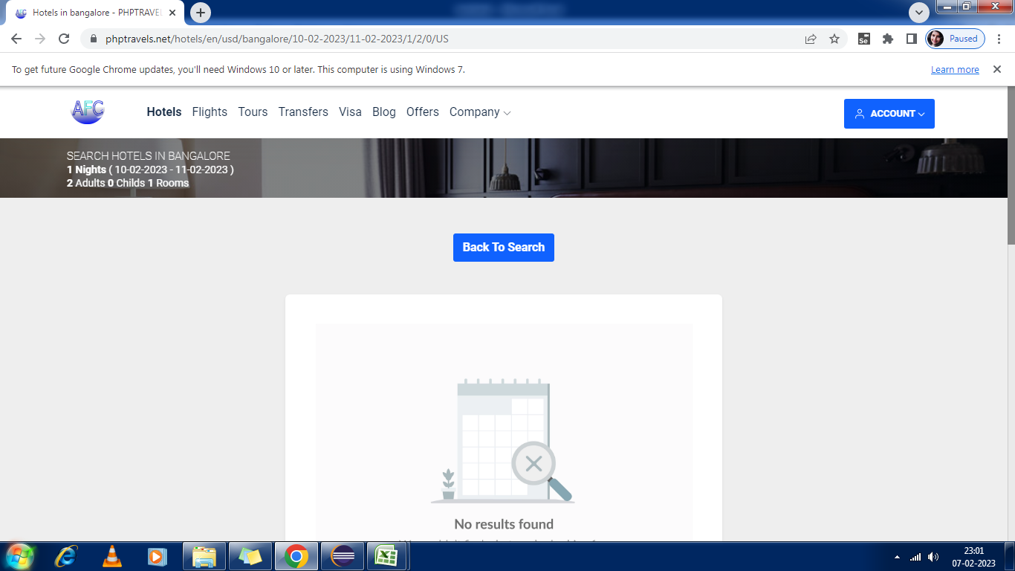

**Bugs in supplier module**

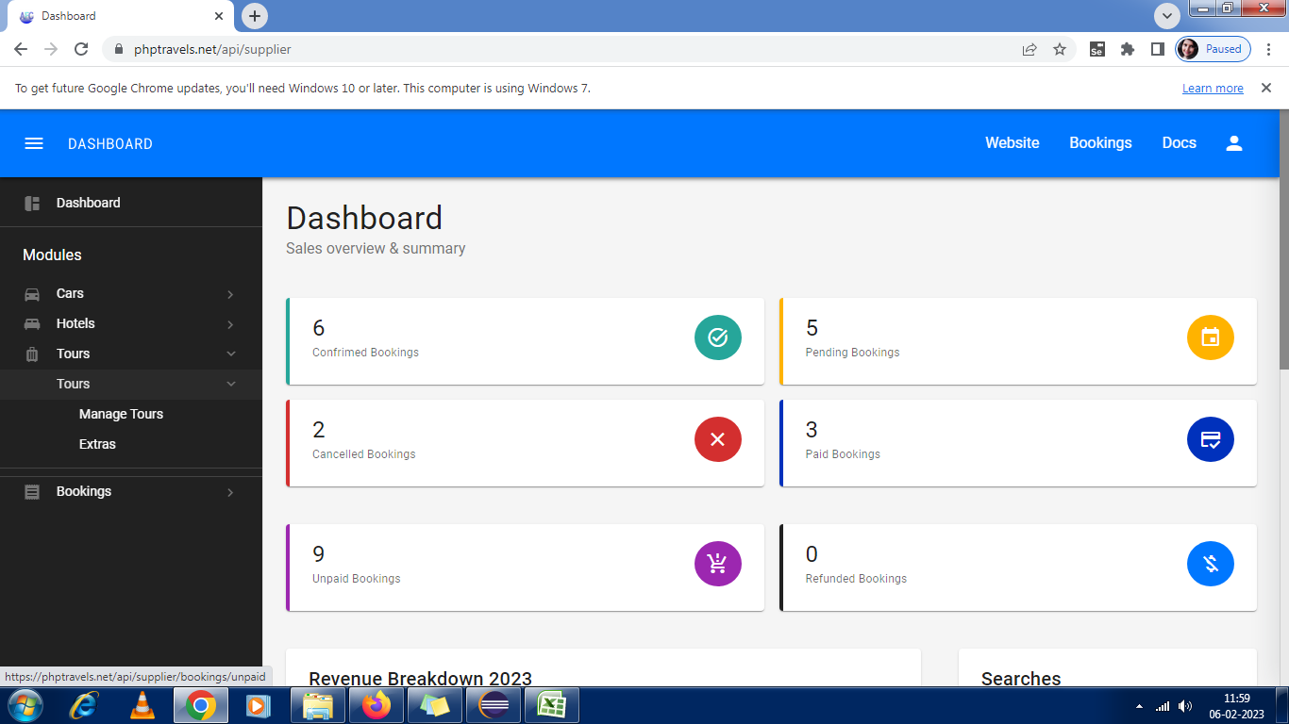

1)Tour page bug

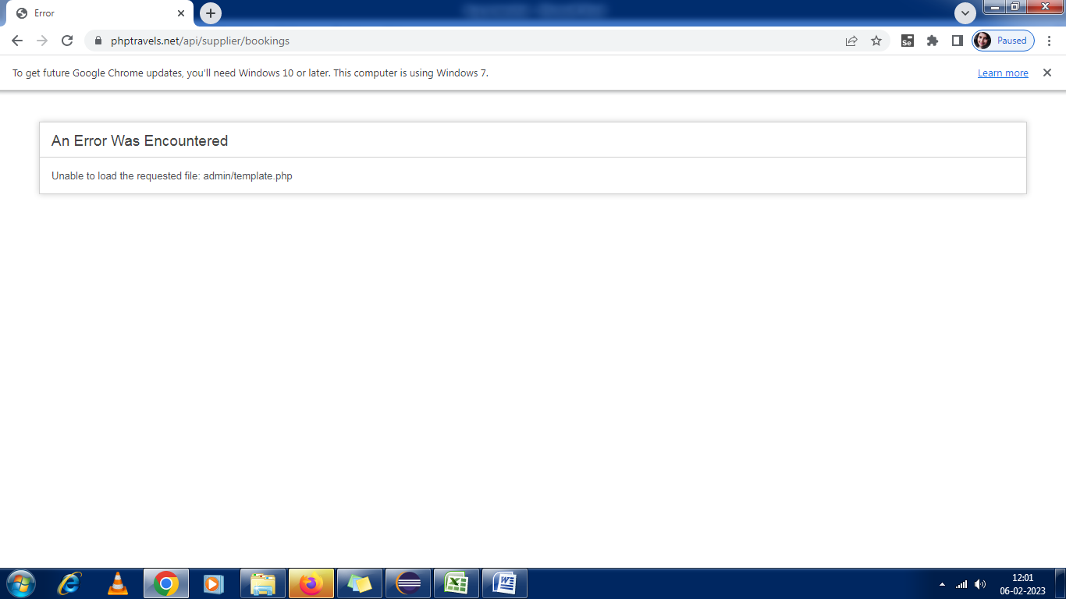

2)Booking page bug

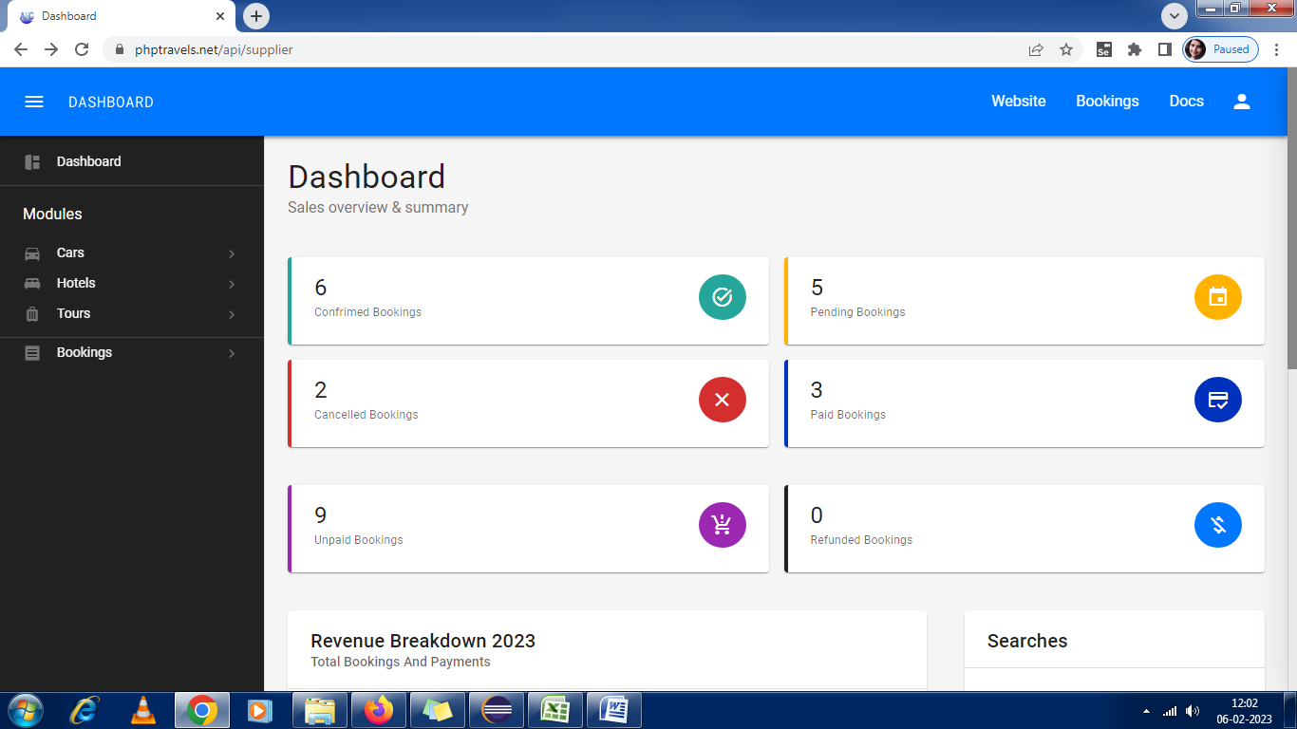

3)Visa Link and Flight link is not added in the dashboard page

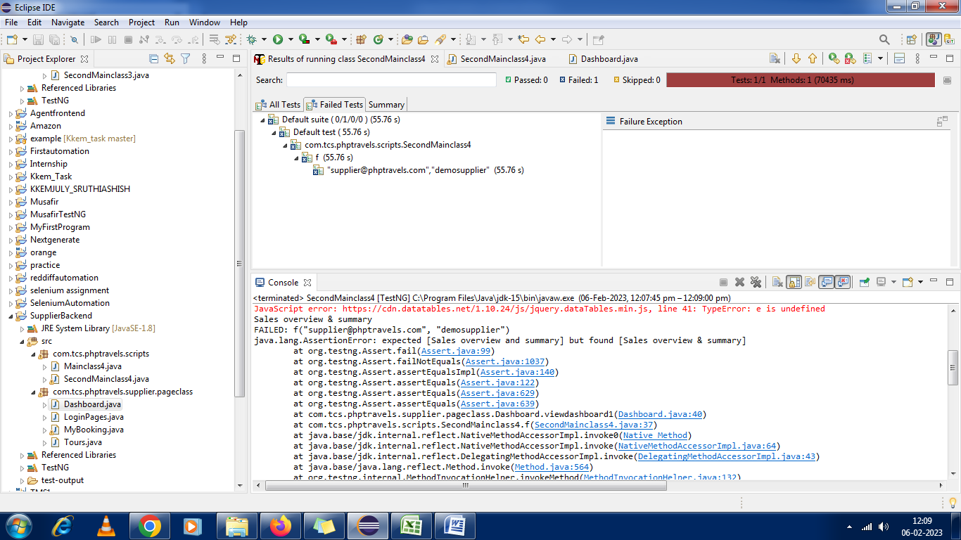

4) Error in finding the text Sales overview and summary

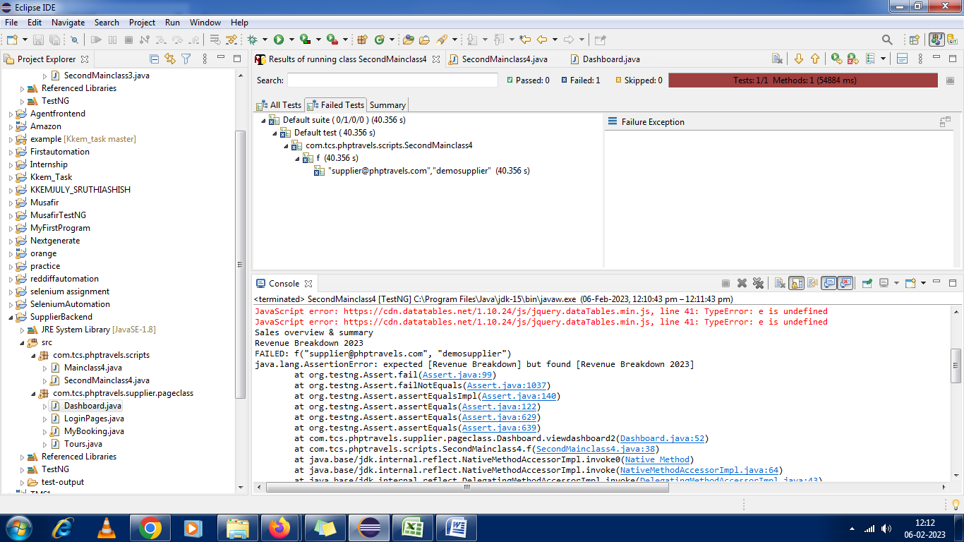

5) Error in finding the text Revenue Breakdown